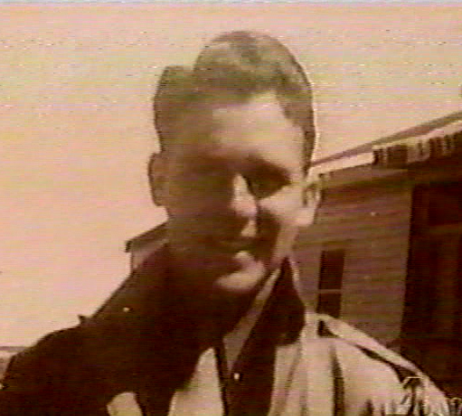
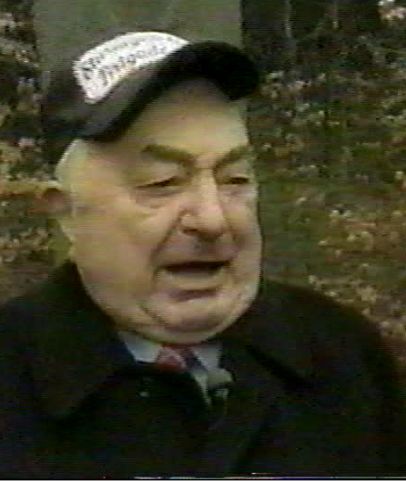
LESTER BORNSTIEN & HANZ GENG
SOLDIERS, ENEMIES
&
BEST OF FIRENDS

FIRST THEY WERE FOES
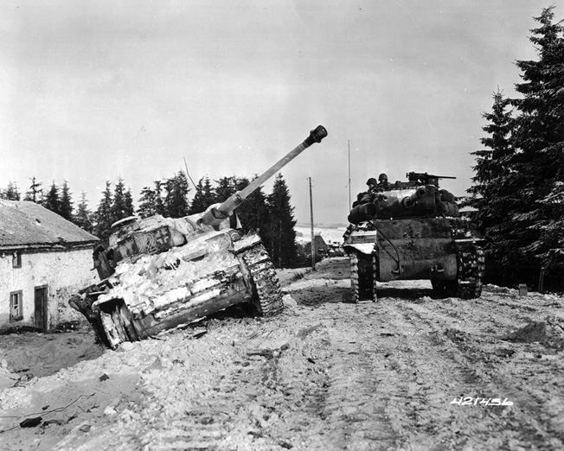
“First I tried to take out the tanks closing in he disabled the lead tank the German commander abandoned the advance due to this attack. You get to a point in time where it's just history. We were at St. Vithand me and Hill were fighting to take this city. I though that was the end of me, standing in the woods I can hear the blasting of trees, I can hear the screaming. Joining the military was popular everyone had a taboo about not being in the army what did we know, there was so much propaganda.”
(L. Bornstien)

THE LETTER
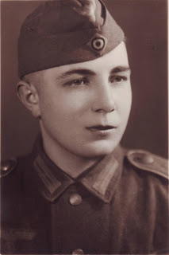
“I wrote letters to both Hill and Borenstien, they agreed to meet with me. When they arrived in Belgum the reunion was full of smiles and great times. I said to them if you know the enemy, you may not kill him.” “I dis not make excuses for the Germans I always admit the issues. We went to an american cemetery in Belgum. Hill and borenstien were the only people still alive to discuss the battle of St. Vith with me, unfortunatley at the time we soldiers were machines to kill.”
(H. Geng)

RECONSILIATION
“Our heroics were lost for years until 1997 when a witness came forward who saw the whole thing. Hanz Geng wanted to meet his former enemies, us, based on emotion, he could finially get the names of those he was ordered to fight against. A Book about this event writen by Hill's son and he called it Reunion”.
(L. Bornstien)

